**MergeExcelFiles | How to consolidate data from multiple excel files into one excel files**

1. Select Loop Each Files in the Folder path
2. 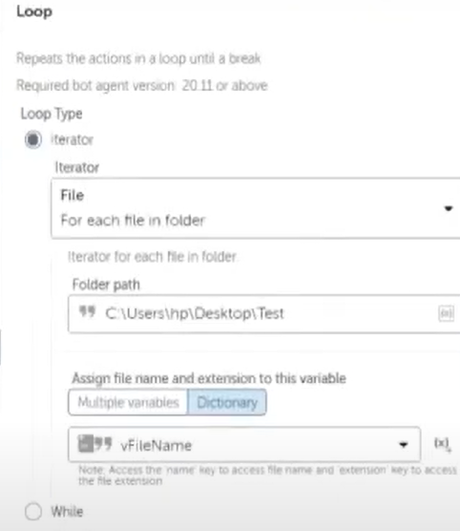
3. Excel Advanced Package Drag Drop open Command
4. 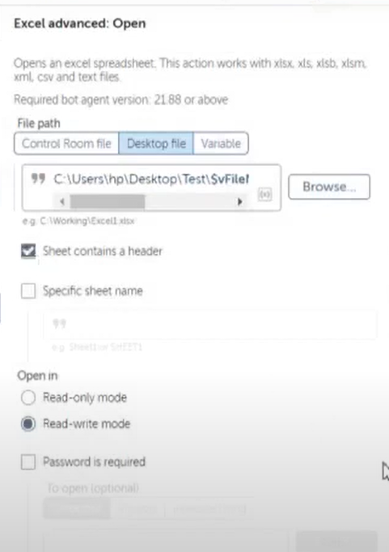
5. Give Session Name as Input Excel
6. Add Get Multiple cell Command
7. 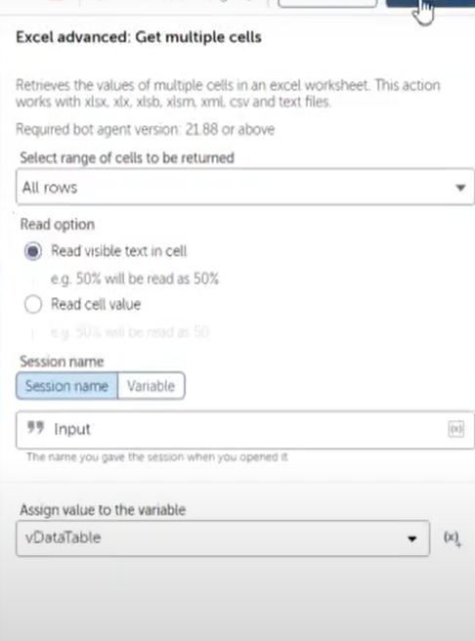
8. Add for each row loop
9. 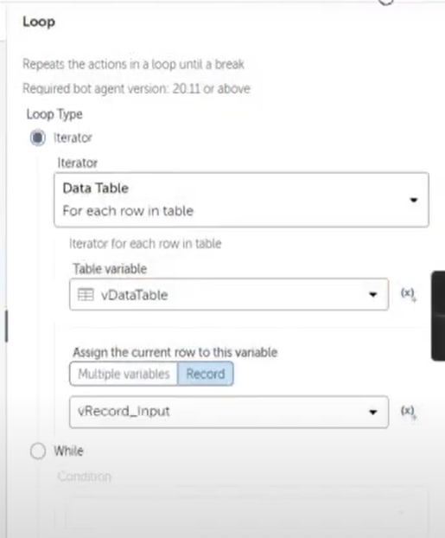
10. Here need to assign above section Table Variable & Current row variable
11. Using String Assign Action assign all required value from row variable
12. Create List Variable lst1,lst2
13. Use add Item Command Assign ID in lst1Varaible
14. Use add Item Command Assign Name in lst2Varaible
15. Close Excel File(InputSession)
16. Select List Iterator Loop
17. 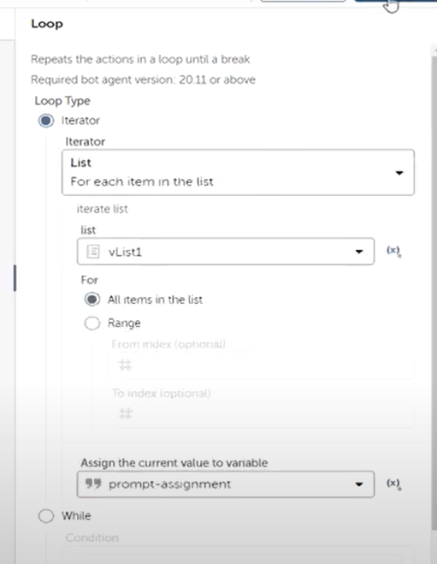
18. Open excel file inside the loop and Map the necessary variable
19. 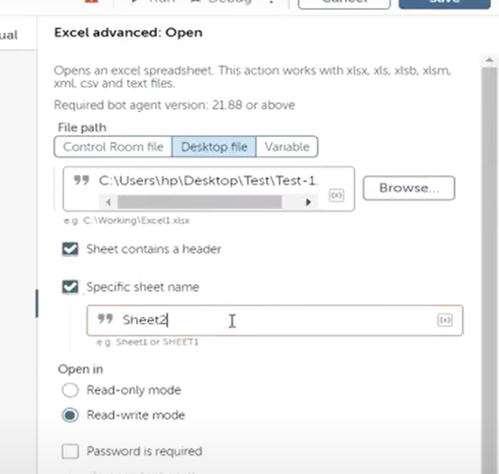
20. Set Cell 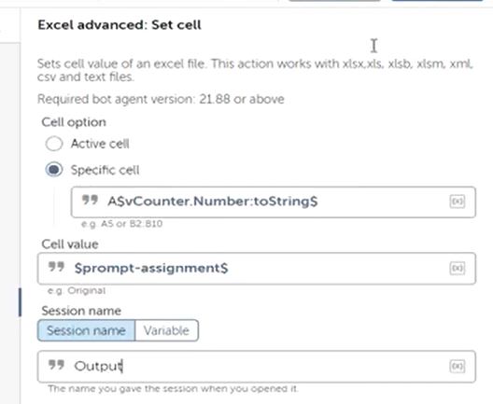
21. From Number Package add the counter variable increment number variable for Specific Cell
22. 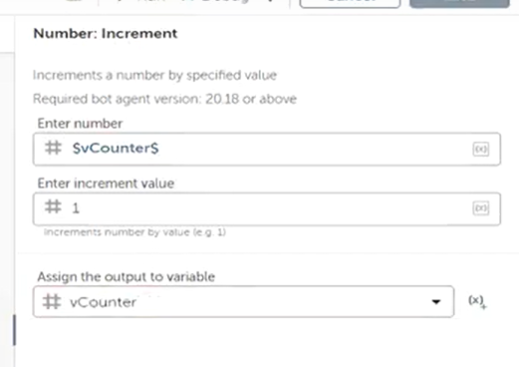
23. Outside Loop add Counter varaiable equal to 2
24. Close Excel vraible

# How to get Number of Rows

In Data Table command using get Number of Rows properties , we get the value

# Run Macro in Automation Anywhere

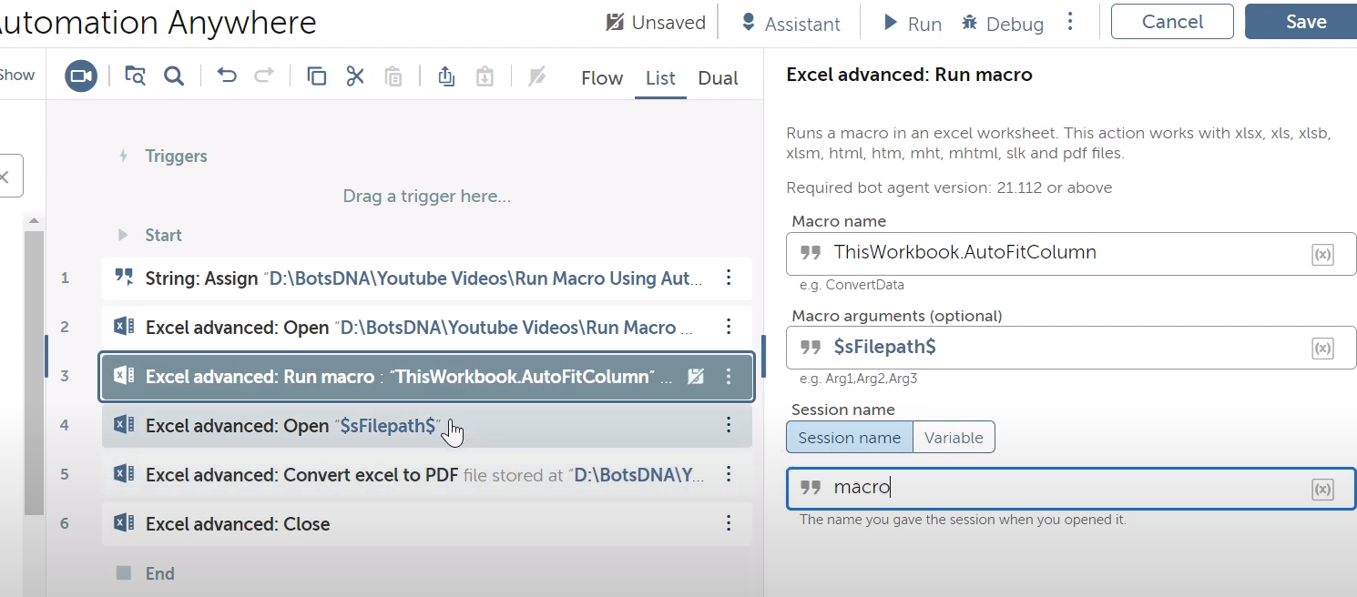

Steps:

Need to open the .xlsm file then use run macro command

Then open excel then call the convert excel to pdf.

Macro code

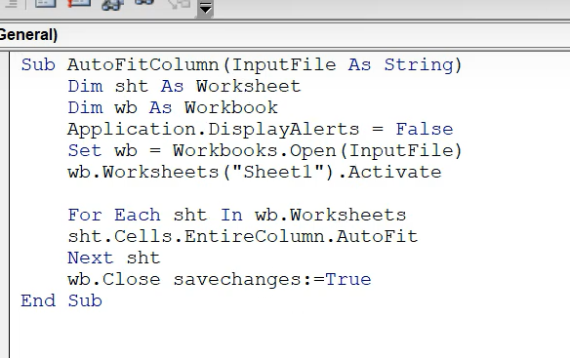

Another Example 2:

# Automation 360,Automation Anywhere,Run Macro, Excel Advanced,Handle macro error inside Task Bot

